Annual

Home Maintenance Schedule

and mold prevention

Like a car, your home needs regular maintenance and occasional tune-ups to stay in tip-top shape. Fortunately, you can complete most of the following tasks yourself by following this season-by-season schedule of indoor and outdoor maintenance.

Spring Home Maintenance

In spring, focus on freshening up your home and tidying up your yard for summer.
Outdoor Tasks:
- Clean gutters and downspouts.
- Inspect roof and chimney for cracks and damage.
- Wash all windows, inside and out.
- Install screens on windows and doors.
- Clean outdoor furniture and air out couch cushions and pillows.
- Inspect the yard, clean up any garbage or branches that might have blown in during the winter.
- Have a small burn pile to dispose of any rotten wood, branches etc. (Don’t burn furniture, mattresses, or household garbage)
Indoor Tasks:
- Test smoke and carbon monoxide detectors when you set clocks forward.
- Wash and change seasonal bedding.
- Dust blinds and vacuum curtains throughout your house.
- Clean kitchen and bathroom cabinets and throw away outdated food, medicine and cosmetics.
- Pull items away from windows and walls to allow the room to breathe and air to circulate\\

Summer Home Maintenance
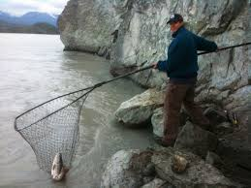
In summer, complete the following projects to keep your yard clean and your home cool.
Outdoor Tasks:
- Walk around your home's exterior and slide open crawl space vents at the foundation.
- Prune trees and shrubs.
- Remove lint from dryer exhaust vent with a long, flexible brush.
- Uncover central air conditioner and install window air conditioners.
- Trim bushes, pull weeds around the foundation of the house
- Inspect for carpenter ants or other potential pests around the foundation of the house
- Inspect outbuildings for structural damage or evidence of pests or rodents
- Cleanup any garbage that might have blown into your yard.

Indoor Tasks:

- Change or clean heating, ventilating and air conditioning filters. Consult manufacturer instructions for your furnace to determine whether you need to change filters more frequently.
- Clean kitchen appliances inside and out, including refrigerator coils.
- Maintain clean drains by adding a half-cup of baking soda followed by a half-cup of white vinegar. After 10 minutes, flush with boiling water.
- Drain or flush water heater.
- If it gets very humid in your home, keep a watchful eye out for mold in your home. Move houseplants outdoors and promptly throw away rotten fruit and vegetables. Wipe up condensation on windows as soon as you notice it.
- To prevent excessive moisture in the home, if you have one, use the barbecue to cook outside

Fall Home Maintenance
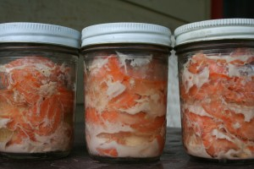
In fall, prepare your home and yard for cooler temperatures and more hours spent indoors.
Outdoor Tasks:
- Clean gutters and downspouts.
- Inspect roof and chimney for cracks and damage.
- Rake leaves and shred to use as mulch or dispose of them based on local guidelines.
- Close or install storm windows.
- Remove hoses from spigots and drain and store indoors, coiled and flat.
- Store outdoor furniture and cushions.
- Test snow blower and inspect snow shovels to ensure they are ready for the winter
- Store a bag of kitty litter or rock salt for ice on walkways and driveways
Indoor Tasks:
- Test smoke and carbon monoxide detectors when you set clocks back in the fall.
- Check windows and doors for weather-tightness and install weather stripping where it's needed.
- Have furnace professionally inspected. Contact the band if you need an inspection.
- If needed, set traps for rodents.
- Dust blinds and vacuum curtains throughout your house.
- Clean kitchen and bathroom cabinets and throw away outdated food, medicine and cosmetics
- Now is the time to check the pantry and ensure your canning is sufficient for winter, double check the seals, dispose of any jars that are not sealed. Toss away anything that looks or smells moldy.
- Declutter, ensure that items aren’t closely stacked in closets and corners. Make sure air can circulate to prevent mold and mildew.
- When cooking or showering, always open a window and ensure vents and fans are working, this will prevent condensation that can lead to mold and mildew.

Winter Home Maintenance
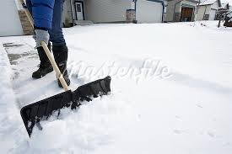
In winter, enjoy energy-efficient warmth and the fruits of your home-maintenance labors. Use this time of the year to thoroughly clean and care for your home's interior while taking a few precautionary measures on the outside.
Outdoor Tasks:
- Walk around your home's exterior and check the crawl space vents located at the foundation. Close any that are open.
- Protect your central air conditioning unit with a cover, and remove and store window air conditioners.
- Clean and store garden tools.
- Move snow shovels and snow blowers to a convenient spot.
- Inspect trees for broken branches and trim back shrubs, especially around the house where they could cause damage to roofs and the end of the driveway where they could potentially block the vision of drivers.
Indoor Tasks:
- Change or clean furnace filters. Consult manufacturer instructions for your furnace to determine how frequently the filters should be replaced.
- Clean kitchen appliances inside and out, including refrigerator coils.
- Maintain clean drains by adding one-half-cup baking soda followed by one-half-cup white vinegar. After 10 minutes, flush with boiling water.
- Keep a watchful eye on the windows, if condensation and excessive water on the windows becomes a problem, use fans and open a window a crack when cooking and showering. Wipe up the water before it drips onto the window sills as this can cause damage to the home. Contact the band if the problem persists because damp and humid conditions in the home can lead to mold and mildew.

Preventing and Removing MOLD AND MILDEW in the Home

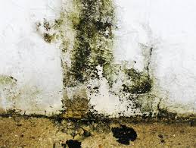 | 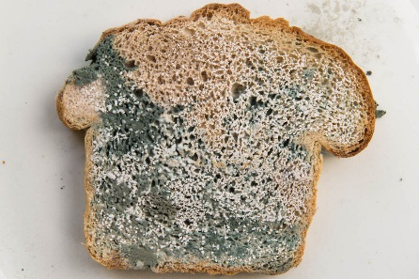 | 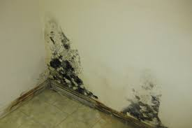

If your home is located in an area that is usually very humid with plenty of rain, then mold could become a big problem. These conditions are ideal for mold to grow and flourish. The presence of mold in your home does not mean that you are a bad housekeeper or that your house is dirty, mold often shows in even the cleanest homes and it is nothing to be embarrassed about. Some simple tricks will help prevent mold from getting a handhold in your home.
Mold and mildew (mold in its early stage) are tiny fungi that quickly grow anywhere there is moisture. They serve an important purpose in our environment by helping to destroy organic materials such as leaves, thereby enriching the soil.
But at the same time, mold can cause a serious health issue for people living in a moldy home. Respiratory problems; sinus congestion; eye, nose, or throat irritation; and headaches are all common symptoms. Infants, children, pregnant women, elderly individuals, and people with existing respiratory conditions are at a higher risk for these problems.
Check for areas in your home where there could be high humidity or water damage, such as a damp basement or crawl space. Mildew and mold can grow on wood products, ceiling tiles, cardboard, wallpaper, carpets, drywall, fabric, plants, foods, and insulation.
These growths can begin to develop on a damp surface within 24 and 48 hours and produce spores that travel through the air. The problem won't go away on its own. Learn how to remove and prevent mold and mildew with these simple tips.

Prevent Spores from Spreading
Mold smells like mushrooms, some people describe the smell as “musty” or “yeasty”. Mold looks like black spots or greenish spots on walls and windows, it may look yellow or white on fabric. On food it may be slimy, hairy or look like foam. Mold will not go away by itself and it spreads very quickly. Moldy items must be properly cleaned or thrown away outside of the house, even mold in the household garbage can become a problem if it isn’t taken outside regularly. It’s easier to prevent mold then it is to clean it. Here are some simple tips to prevent mold and mildew in your home.

- Use dehumidifiers, fans, and open windows to help reduce the moisture in your home. Be especially vigilant during hot, humid months. During the winter don’t allow moisture to build up on windows, wipe up the water as soon as you notice it and keep a window open a crack when cooking or showering.

- Fix plumbing leaks as soon as possible.

- Do what you can to prevent rain water from seeping into your home. Check potential problem areas regularly.

- Clean the fabrics in your home routinely and keep them dry.

- Store items in dry, well-ventilated areas. Avoid storing stuff in cardboard boxes, if possible use plastic storage bins with lids. Make sure items are dry before storing them.

- Watch for the presence of mold in the house: dirty dishes, plants, rotten fruit and outdoor clothing can all have mold on them, wash them, throw them away or take them outside as soon as you notice the presence of mold.

Keep Your Bathroom Fresh
Few rooms in the home see as much moisture and humidity as the bathroom. Be sure your bathroom stays well-ventilated. An exhaust fan will help circulate the air and remove moisture more quickly. These additional actions will help keep your bathroom fresh and mold-free.

- Spread towels out after use so that they dry more quickly.
- Minimize containers left in the shower for cleaning ease and better circulation.
- Wipe down the shower with a clean towel or squeegee after its last daily use.
- Choose shower curtains that dry and clean easily to help avoid soap residue, which fosters mold.

Freshen Fabric and Upholstery
Avoid sending mold spores into the air and throughout the house by first taking fabric and upholstery that's mobile outside. Brush off as much of the mildew as possible. Then treat these pieces individually as follows.

- Fabric should be laundered in chlorine bleach and hot water. If chlorine bleach is not a safe option for the material, soak it in oxygen bleach and hot water for a half hour, then wash as directed. Take it outside to dry in the sun if possible.

- Upholstery that you can't take outside should be vacuumed first. Replace the vacuum bag or take the canister outside to clean.

- Then mix 1 cup of ammonia with 1 cup of cool water. (Chlorine bleach and ammonia should never be combined due to the resulting toxic fumes.)

- Using a clean white cloth, sponge the stains with the ammonia solution. Blot until all the liquid is absorbed. Repeat the process until the stain disappears.

- To remove the resulting ammonia solution, sponge the area with cold water and blot.

- Dry thoroughly with a fan or hair dryer set on cool.

If you're dealing with a mildewed shower curtain made of durable fabric, follow these steps for cleaning it.

- Wash using a solution of 1/2 cup liquid disinfectant to 1 gallon of hot water.
- Rinse with a mixture of one cup lemon juice and one cup salt to a gallon of hot water.
- Wash with detergent and bleach (using color-safe bleach on color fabrics).
- Rinse in clear water.

Clean Mildew-Stained Carpets
Start by thoroughly vacuuming the affected carpet to remove as much of the mildew as you can. After you are done, either throw away the bag or clean the canister outside. Then proceed as follows.
- Briskly mix 1 tablespoon of liquid laundry soap and 2 cups of cool water.
- Apply the suds to the stained area with a damp cloth, sponging lightly.
- Repeat until the stain is gone, then rinse.
- Dry the area completely.

Revive Stored Wooden Furniture
- Vacuum mildewed wood furniture with a soft brush to remove any loose spores. After you are done, either throw away the bag or clean the canister outside.
- Quickly wipe off any stains using a light touch.
- Rinse the area with a damp cloth, let dry, then polish.

If It's Too Late, Throw it away
If the mold and mildew on your fabric, upholstery, carpet, or furniture is beyond cleaning and drying, throw it out or call a professional cleaning service. Don't take a chance with the potential health risks that mold and mildew can cause you and your family.

Don’t take moldy fabrics or belongings into a new home. Introducing mold spores into a new environment could potentially lead to another episode of uncontrolled mold growth.

