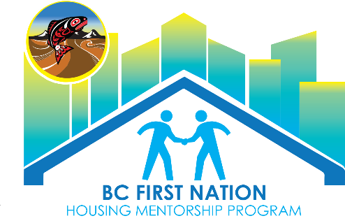

Maintenance Worker Job Description

Title | Maintenance
Department(s) | Public Works
Reports to | Housing Manager

Job description:

To be an integral part of the Community on a day to day basis in performing tasks that pertain to maintaining a clean, healthy, and safe environment.

Duties & Responsibilities:
- Assisting with gardening
- Landscaping
- Power washing
- Basic home maintenance, cleaning gutters, exterior painting, cleaning chimneys
- Painting
- Small repairs such as doorknobs, drywall patches,
- Basic plumbing such as snaking a toilet, fixing a dripping faucet
- Maintaining garbage and recycling receptacles
- Maintaining roadway and public areas, shoveling, plowing, clearing brush, picking up windblown trash and debris, filling potholes
- trimming hedges and trees
- grass cutting common areas, pulling weeds, weed whacking around power poles and fences

Qualifications & Requirements:
- Good interpersonal communication skills
- Ability to perform repetitive tasks
- Ability to lift up to _____ lbs
- First Aid training is desirable
- Familiarity with the use of the following equipment:
- hand and power tools,
- lawn mower,
- weed eater,
- pressure washer,
- spray equipment,
- rototiller
- Bobcat

Wage:

Based on qualifications and experience.

