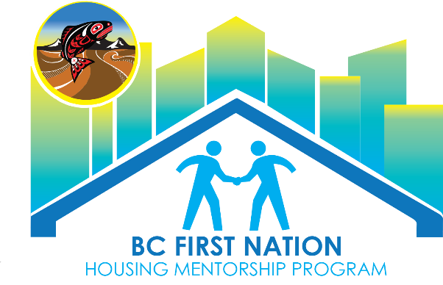

Sample Funding Proposal Template

This Proposal template is provided to you by BCFNHMP as a sample to be modified to suit your First Nation. This proposal outline is a good starting point for any funding program that does not provide an application template. It is also an excellent Project Planning Tool.

Executive Summary

Guideline: Summarize the project and be sure to include the following projected dates: project commencement date, project completion date, and start date of operation. Use this section to prove that your Band has the required experience, knowledge and credentials to undertake the project..
Attach a BCR indicating that the project is supported by Chief and Council and confirming any in-kind/cash contribution by your Band.

Community Need

Guideline: Summarize and demonstrate your community’s need for the project. This may take the form of a community needs assessment and/or a relevant data analysis. You must include an explanation of how your proposed project will meet the needs of your community and will provide new or additional services/resources/access that are not readily available in the community including steps you have taken to avoid service duplication.

Project Description

Guideline: Identify the type of project, proposed location, and detailed description of work to be undertaken. Include details of planning to date and origin of the project. Use a spreadsheet or table to organize schedule of activities, include a timeline if possible. State objectives of the project, target audience, anticipated # of participants, anticipated number of people who will directly and indirectly benefit, outcomes, outputs, and community benefits.

Financial Standing

Guideline: Often funders ask bands to provide documentation regarding the nation’s financial standing. This might include, but is not limited to: an audited financial statement, a letter from a lending institution stating that the band is in good standing and/or a BCR declaring that the band has the financial capacity to manage the funding should you be successful.
Budget

Note: Refer to the specific Funding Program Funding Guidelines for more information regarding the documentation required.

Guideline: Complete and include a detailed Proposed Budget for the Project, and Operating Budget if required. Include any detailed quotes from facilitators, equipment/project supplies and an outline of anticipated professional fees; consultants, contractors legal counsel etc. Include venue rental expenses, travel costs, office supplies, honourariums, food, printing, copying, communication costs etc. as applicable. Be sure to provide information related to other potential revenue, funding sources and in-kind or cash contributions from your band or partners. .
Sometimes an organization is required to contribute a minimum percentage towards the total cost of the project. Confirmed sources of financial contribution should be included, do not forget to add volunteer hours. Describe the total value of the volunteer labour contribution, we have included a Volunteer Labour template below.

Accepted rates for volunteer labour are:
$50.00 per hour for heavy machinery and operator
$20.00 per hour for skilled labour
$10.25 per hour for unskilled labour

Type of Labour | Number of Hours | Rate | Total
Total Value of Volunteer Labour

Human Resources

Guideline: Describe how your project will be coordinated. If you feel it is necessary, include a responsibility matrix, this is a table identifying tasks and the name of who is to be responsible. If a timeline is relevant, this is a good place to include that information. This is particularly helpful if the project will be facilitated by a committee or group organizers.

Timeline

(use this template only if you haven’t included a timeline somewhere else in your proposal)

List the start and finish dates for the main activities of your project. Add or delete activities as necessary.
Activity | Start Date | Finish Date

