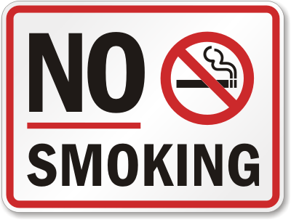

- NO smoking within 3 meters of doors and windows.

- NO smoking on decks or steps.

- NO smoking inside the units.

Strictly enforced as Housing Policy/By-law #_______

Thank you for being considerate of your neighbours

This Photo by Unknown Author is licensed under CC BY-SA-NC

